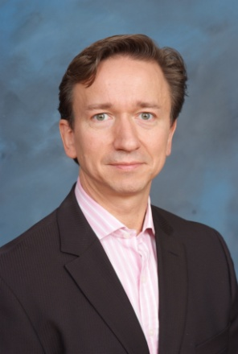
Andreas M. (Andy) Zynga, CEO, NineSigma, Inc.
Andy Zynga joined NineSigma in February 2008 as CEO of NineSigma Europe and was appointed CEO of global operations in September 2009. Prior to assuming the global CEO role, Andy successfully grew the company’s European business, adding a significant number of new customers and assembling an experienced team of professionals across all functions.

During his 25-year career, Andy has built 4 high tech and service businesses successfully in both Europe and the U.S. He also spent 6 years at KPMG Consulting (now Bearingpoint) in Germany and London where he successfully grew a division of the Information, Communication, and Entertainment (ICE) Consulting Practice into a major international player. Prior to joining NineSigma, Andy spent 4 years as a member of the Executive Committee of Telindus, a global network integrator and outsourcing company with more than $1B in revenues and 3,000 employees in 14 countries.

Andy earned a dual Masters degree in Business Administration and Mechanical Engineering from the Technical University of Berlin, Germany.

